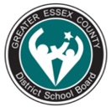**Morphology for Meaning: Use of Slide Decks**

**Melinda Hinch, Speech-Language Pathologist, GECDSB**

**Morphemes and Morphological Awareness**

*Morphemes* are the smallest units of meaning in a language. The dictionary defines a morpheme as “a word or part of a word that has a meaning and that contains no smaller part that has a meaning.” Morphemes include *base* words and *roots*, *prefixes*, and *suffixes*. Some morphemes are *free* – they can stand alone (e.g., fish*, run, quick, the*). Other morphemes are *bound* – they cannot stand alone and must be attached to another morpheme (e.g., *re-, un-, geo, phon, -ed, -ment).*

Examples include:

* The word *dog*contains one free morpheme
* The word *cats*contains one free morpheme (dog) and one bound morphemes (s)
* The compound word cupcake contains two free morphemes (cup, cake)
* The word *subway* contains one bound morpheme (sub) and one free morpheme (way)
* The word *transportable* contains three bound morphemes (trans, port, able)

*Morphology* means the study of word parts, and *morphological awareness* refers to the ability to identify and manipulate the morphemes in words.

The Ontario Ministry of Educations published Language Foundations Continuum for Reading and Writing, Grades 1–4, Overall Expectation B2. This document identifies specific morphemes that require explicit instruction to support reading and writing acquisition.

**Resources Utilized for Morpheme Slide Decks:**

The Morpheme Project [https://thesyntaxproject2022.squarespace.com/morphology-lessons](https://can01.safelinks.protection.outlook.com/?url=https%3A%2F%2Fthesyntaxproject2022.squarespace.com%2Fmorphology-lessons&data=05%7C01%7CMelinda.Hinch%40publicboard.ca%7Cb48c28958eff4b70519408db7737a05f%7C6ce0010e3b3a4614a2dbdb73b18f219f%7C0%7C0%7C638234853974907229%7CUnknown%7CTWFpbGZsb3d8eyJWIjoiMC4wLjAwMDAiLCJQIjoiV2luMzIiLCJBTiI6Ik1haWwiLCJXVCI6Mn0%3D%7C3000%7C%7C%7C&sdata=1VTITVJxH%2BkQPjNMZrhAtJC4TYrR98wEfos6%2BzvMMGY%3D&reserved=0) has been aligned to the MOE Language Curriculum 2023 and adapted accordingly. Images are from Pixabay or personal photos.

Please note that using UFLI for word recognition or affixes may not be enough for many of our students requiring additional language support. The prefix and suffix slide decks can support this area of need.

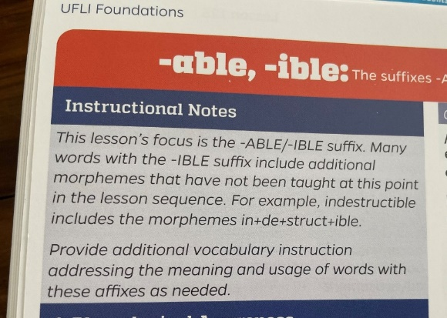

**Slide Decks:**

*Morphology for Meaning* consists of separate prefix and suffix slide per grade.

Each morpheme has five slides:

* Morpheme definition with a list of examples
  + The educator reads the text and discusses with the class.
* A photograph or image highlighting a word containing the morpheme.
  + The educator reads the sentence(s) under the image or photo. Students can imitate the sentence or create their own using the targeted morpheme.
  + Educators can add additional photos or images and have students use the morpheme in a sentence to describe.
  + Educators can add pictures from content-based shared reading or images from other media sources to support morpheme development across the curriculum.
* Let’s Talk It Out
  + The educator supports the students by reading the sentences with the identified morpheme. Students can create their own sentences. Additional words can be added from first slide.
* Fill in the Blanks
  + Three words containing the morpheme are read aloud by the educator. The educator reads each sentence and the students identify the correct word to complete the sentence.
* Let’s Make New Words
  + Students write the affixes and create words.

Educators are encouraged to extend the slide decks with word tree activities and matrix boxes.

**Frequency of Implementation:**

* Dependent on needs of the classroom.
* The slide decks are quick to implement. Consider teaching one morpheme per week.
* Extend into cross-curricular activities.

Please contact me with questions or comments,

Melinda Hinch, M.Cl.Sc., M.Ed., Reg. CASLPO

Speech-Language Pathologist

[melinda.hinch@publicboard.ca](mailto:melinda.hinch@publicboard.ca)

Greater Essex County District School Board

